Xbox Executable Model
If you have questions or comments, contact your account manager.
Overview
The Xbox™ video game system from Microsoft employs an executable format that is optimized for the fixed nature and purpose of the console platform. This document describes the overall structure of Xbox executables (XEs, which have the file extension .xbe) and highlights the differences between XEs and the Win32 model.
Base Format
Unlike a standard personal computer, the Xbox console is a single-process machine. When a title is running, it is in complete control of the hardware. On traditional personal computers, applications are normally handed a highly sanitized and virtual view of the actual hardware as seen through the operating system. On the Xbox console, titles will have near complete control of the hardware itself. All Xbox Title Libraries (XSS) behave within the boundaries of a title’s process. In this system, XBEs are monolithic entities encompassing all game and system software as opposed to the more distributed model typical of personal computers. Figure 1 presents a greatly simplified view of this difference.
Additionally, unlike the shared and general-purpose environment of Microsoft® Windows®, Xbox is designed and optimized toward gaming applications. Accordingly, the Xbox executable format does not contain support for many common features of the Win32 model. The following points summarize these differences:
- No support for dynamic link libraries (DLLs). Unlike Windows, Xbox has no concept of shared dynamic code. As figure 1 indicates, all code is a static part of the executable (save for a small portion of kernel code resident on every box). While this layout requires some minor changes to the typical project architecture, it simplifies the model and removes any chance of the dreaded DLL problems. Developers are assured that a title will always run with the same code base it was initially tested against. Because all system services (such as the Xbox Title Libraries) and all middleware are provided to titles as static libraries, the linker automatically throws out unused routines. This results in greater code efficiency and smaller code size. (However, static library linking also introduces a higher chance of name-space collision. Developers should follow a consistent name-space plan when developing titles, such as embedding functional units in different name spaces, using documented naming schemes, and so on.)In this file is e

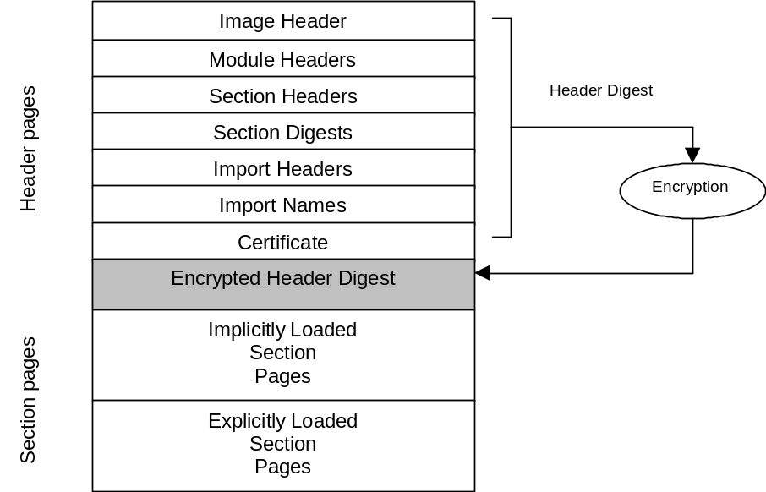

- I

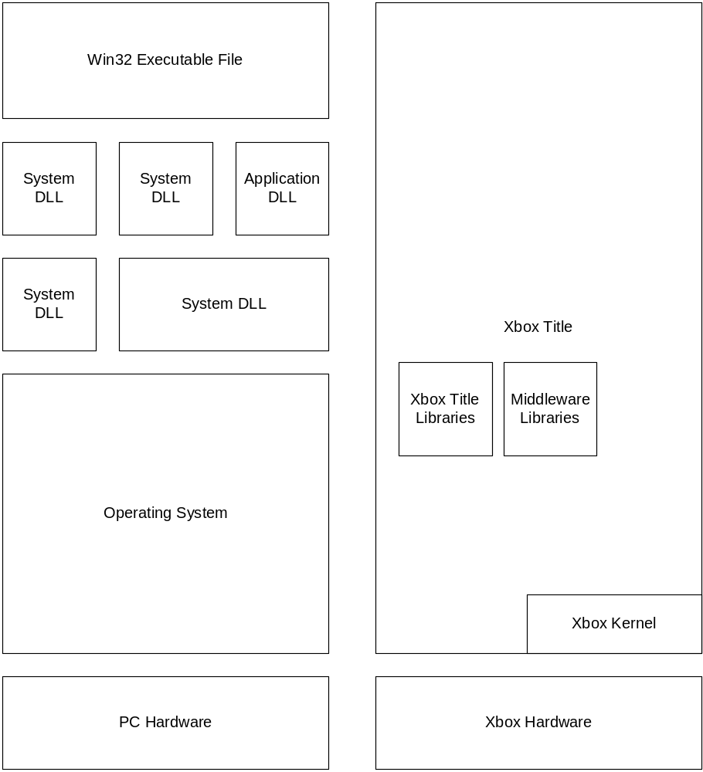

Figure 1 Win32 structure (left) versus XE structure (right)

- No support for resources. The familiar (to some) Win32 resource APIs are not present within the Xbox Title Libraries. In general, executable resources are not the most efficient storage means for the types of resources likely to be found within games. Developers accustomed to using resources for text and other content will have to devise another method for retrieving this data on Xbox. The Imagebld image-building tool will emit error messages when it detects compiled resources within a source executable.
- Complete control over code sections. An XE image comprises one or more sections of code and data. By default, all sections are preloaded into memory when the title is launched. However, titles can delay load most sections by using the /NOPRELOAD switch within Imagebld. Regardless of the initial time loaded, most sections can be shuffled in and out of memory using the XLoadSection and XFreeSection libraries. This capability allows title developers to create monolithic XE files larger than the physical memory of the system and then pull sections in and out as needed. Sections are the only way to manage code in memory. The concepts of LoadLibrary, GetProcAddress, or FreeLibrary that Win32 developers may be familiar with are not available.
- No easy process switching. The Xbox console is a single process machine. The only way to switch to a second process is to cause the machine to reboot. Although there will be a mechanism to make fast warm reboots as painless as possible, developers will not be able to use CreateProcess() or exec() as they would on other platforms. Developers should investigate the reboot feature as well as the support for code sections when determining how to design their games.
- Secure. XE images are digitally signed during the certification process to ensure that only unmodified, approved images run on Xbox. During development, title developers are given special test certificates to circumvent this protection.
Managing Sections
As previously mentioned, the Xbox console features complete control over code using the concept of multiple sections. By default, all code in an executable is placed in the .text section. This section is among those that can never be unloaded. This section describes how developers create and manage additional sections.
More information on reserved sections will be available in future releases of these specifications.
Creating New Sections
A title developer can create a new section by using the #pragma directives. A developer can use #pragma alloc_text to place a specific function within a section. To place several functions and data within a specific section, the developer uses #pragma code_seg. Examples 1 and 2 show this in context.

HANDLE AiCreateEngine (DWORD CreationFlags);
BOOL AiDoWork (HANDLE Engine, AI_PARAMETERS AiParms);
VOID AiDestroyEngine (HANDLE);
//
// Make AI engine delay load. We won’t use this code during certain points of the
// game.
//
#pragma alloc_text(“AI_ENGINE”, AiCreateEngine)
#pragma alloc_text(“AI_ENGINE”, AiDoWork)
#pragma alloc_text(“AI_ENGINE”, AiDestroyEngine)
Example 1 Using #pragma alloc_text directives
//
// This entire file is part of the physics engine.
// This is only used during certain areas of the game -- use
// code_seg to control it on a section level.
//
#pragma code_seg ("PHYSICS")
void init_physics (DWORD flags) {
.
.
.
};
//
// more code..
//

//
// This is the end of physics code.
// Reset segment to default code section.
//
#pragma code_seg()
Example 2 Using #pragma code_seg directives

Managing Sections
Once a developer has created non-default sections, those sections can be loaded using XLoadSection. Sections can be freed using XFreeSection. Both of these libraries operate via reference counting. If a copy of a particular code section has already been loaded into memory, XLoadSection only increases the reference count. Similarly, if the reference count of a particular section is greater than zero, XFreeSection only decrements the count.
Sectioning of Xbox Title Libraries
The Xbox Title Libraries will be available in various sections so that titles can manage the use of system services granularly. More information on XTL sections will be available in future releases of this specification.

